**Web Interface**

**5.1: Login Page**

User enters the Username and Password if he already has an account with Facebook and can login to his with his credentials

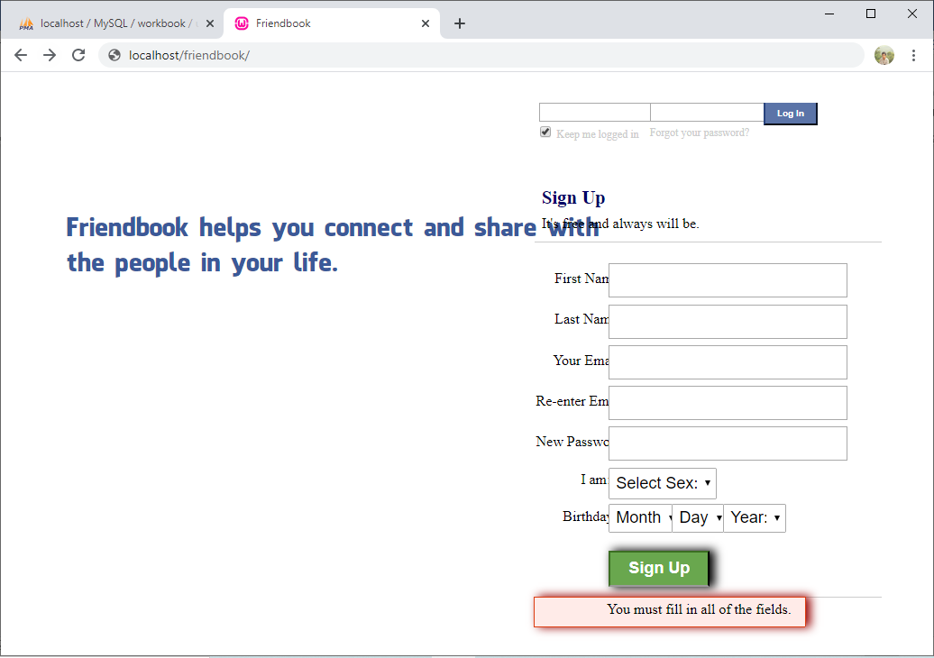

Post Status

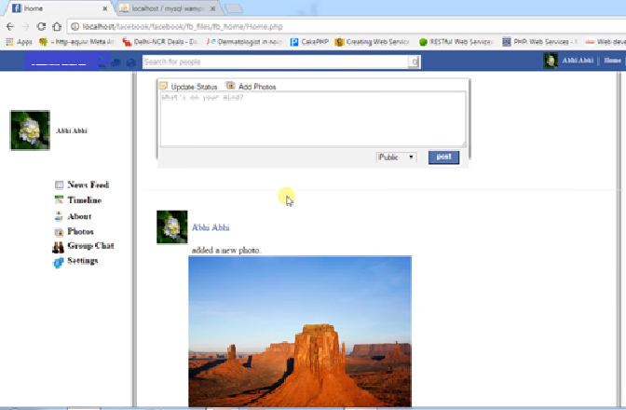

ADD Cover Picture

